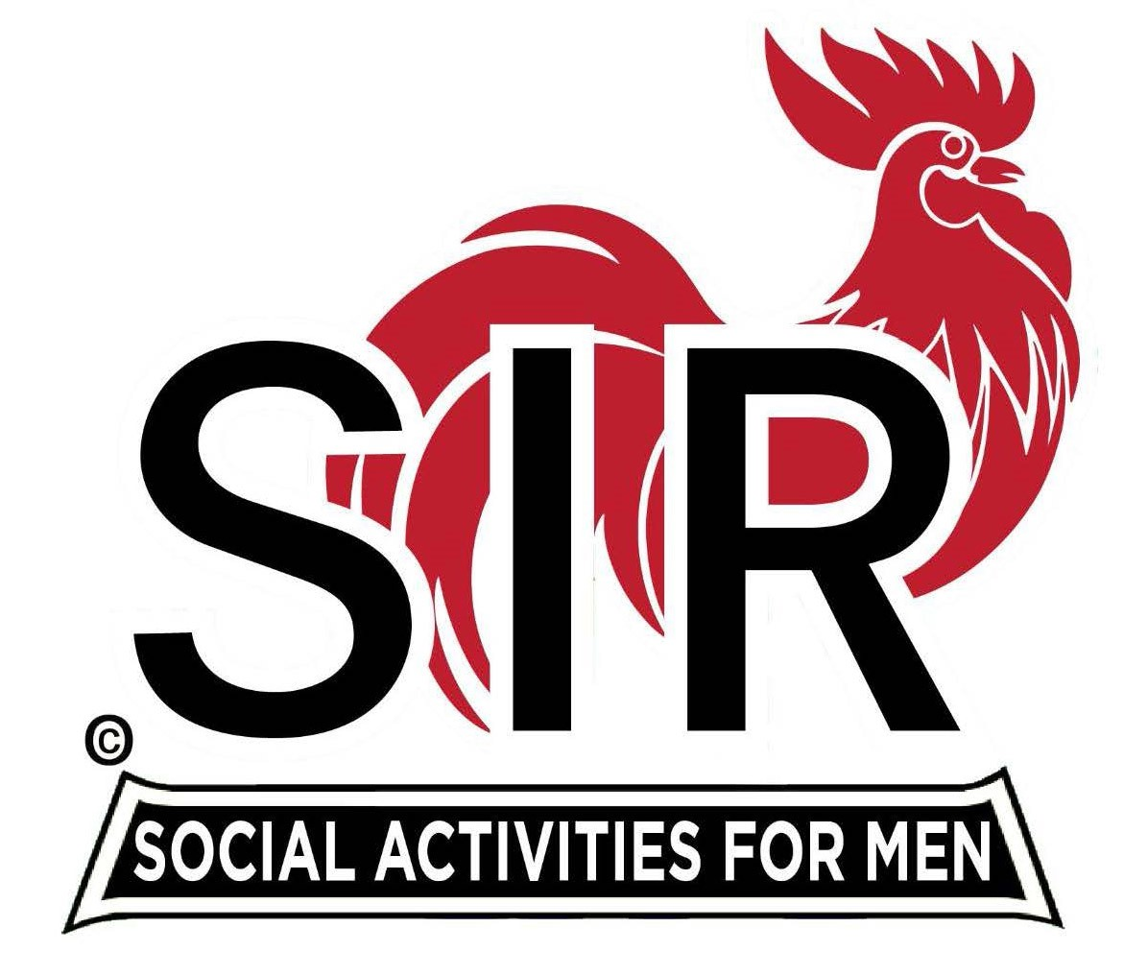
Las Trampas Branch 116
Luncheon Meeting Agenda
March 18, 2024, 10:30 AM

10:30 Check – In
Greeters at the door – Dan Lawrence, Joe Datzmen
Treasurer Table – Al Satake, Charlie Guthrie
Name Tags Table – Dennis Snarr, Mike Schneider
Raffle Table – Ben Bryce, Bob Huck

11:25 Five Minute Call

11:30 Call to order:
Pledge of Allegiance – Big Sir
Invocation and Prayer for Those Ill and Tribute– Terry Sherman

11:40 Branch Updates –
- New Member: Harvey Widroe; Former Orinda Member
- Guest: Dr. Noel Concepcion; Sponsor Peter Loew

12:00 Lunch Served

12:20 Activity Chairs Report - Mike Ward

12:25 Story Teller – Roger Craig

12:30 Introduce Speaker – Allan Farbman

1:05 Speaker Thank You – Bg Sir

1:10 Raffle Drawing – Ben Bryce, Bob Huck
Birthday Boys (December, January) – Little Sir – Paul Russell
Sing Happy Birthday – Music – Dave Williams

1:20 Sing “God Bless America” – Dave Williams

1:25 Closing Remarks / Adjourn – Big Sir

